# PRD

link to other file

**-**[**marketing**](2.Marketing%20Guide%20template.docx)

**-**[**training guide**](3.Training%20Guide%20for%20Sales%20and%20Customer%20Support%20Template.docx)

**-**[**user guide**](4.User%20Guide%20Template.docx)

**-**[**launch email**](5.Launch%20Email%20Template.docx)

**Background information about the industry or the problem**

-KP’s project : the preventative care space to help their patient base increase physical activity and improve on healthy habits. While the overall goal is improved patient satisfaction and well being, the specific financial goal is reduced cost by emphasizing improved health prior to any adverse conditions developing. Overall, KP wants to decrease spending on conditions such as type 2 diabetes.

type 2 diabetes : blood glucose levels are too high, body does not make insulin well

-cause : exact cause is unkown, but possible factors are

1. genetics

2. environment

3. obesity

4. inactive

KP’s project solution : build an App to decrease spending on type 2 diabetes.

-app : focusing on three factors which are cause of type 2 diabetes.

-environment

-obesity

-inactive

problem : type 2 diabetes, lack of physical activity, bad habits

-there are difficulty helping patient remotely

-bad environment may block effort to cure type 2 diabetes

-there are not much support when patient is in home

-need internal & external motivation to transform bad routine to good routine

target market : app store_fitness category

-category : main concept of this app is motivation.

-TAM : 22.4b

-Area : US and english only

risk factors :

-business

-packback period postpone or deficit

-quality

-user satisfaction unknown

-user unfriendly

-UI/UX problem

-product

- unexpected bugs

mitigated plan :

-business

-consider long term benefit

-add extra features

-add ads

-quality

-iterate base on feedback

-product

- update customer guide

competitors : fitness app

-fitbit

-market share 57%

-strong S/W, H/W

-Nike

-market share 11%

-brand name

-worldwide scale

product goals : achieve our vision and mission

-vision : increase physical activity, form good habit, reduce health care cost in the future

-mission : motivate patient or user to transform habit

-decrease 10% of patient who suffer type 2 diabetes

bussiness goal : increase hospital revenue

-marketing : the vision from the app can be great message

-more patient will visit as app user increase

-revenue : extra revenue from app

-reputation : patient satisfaction increase and app can be great strength

Solution : solve environment problem to become healthy

-Motivation is key feature

-provide reason to lose weight

-understand own body condition

-step by step process to lose weight

How : with mobile application

-below are steps for using app

1.test the body condition

2.base on the body condition, app gives appropriate mission to be physically active

3.when patients accompolish the mission, they get points

4.some patients can get stars when they constantly finishing mission well

5.with points and star, patient can get discount on their health care cost

price strategy :

-Price : Freemium

-value : focusing on type 2 diabetes patient that user can expert support though app

-cost : the cost for building app is relatively low compare to building preventive space

-price discrimination : base on loyalty, points and star from mission increase

-Discount : KP’s patient can get discount

-people who invite other

-people who upload on blog, sns can discount

-Offerings : app user can get speical treatment in KP’s preventive space

-stars are given to honorable user, with that star, speical reward are given

Business : relate to revenue

-average # of transform from free user to pay user

-average # of new user

Quality : user satisfaction

-rate of reteintion

-app store review

-Q/A number and content

Product : stableness and technology

-# of bugs or issues happen

-accuracy of result from user health test

Checklist of Team : before launch

-legal and compliance

-legal law in US

-app store regualtion

-customer service

-user feedback

-marketing

-channel decision

-market massage

-sales

-price guide

-contract

Post launch data : 5 weeks

-number of new users

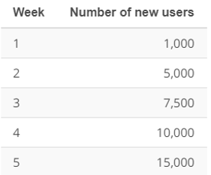

-number of retaintion

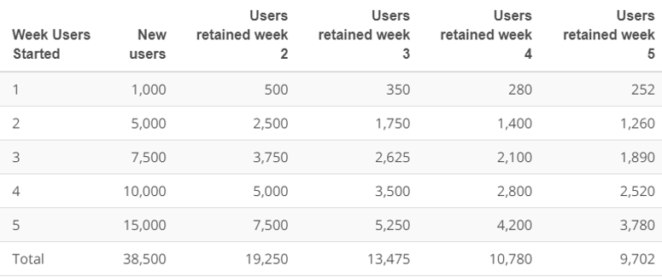

### Key Features & Scope

P0 / Reward system

* Motivation is the main feature of this app. We are giving rewards to motivate patients to become more physically active and form good habit.

P2 / Star system

* Giving star to users who are constantly accomplishing a mission is nice to have. Because we are still giving points for points after finishing the mission.

P0 / health test

* Patient health test is necessary. Because in order to give a proper activity mission, we have to know the patient's body condition.

P0 / sign up

* To manage user information, signing up for an application is mandatory. There is no better way to manage users.

P1 / sign up with google, instagram, facebook

* It is nice to have functions. Because people will be less stressed. However, it is for user friendly purposes, so it could not block for making MVP.

P0 / Q/A

* the main feature of this app is motivation. the only way user can communicate with us is Q/A. Therefore, this feature is must have.

### Core UX Flow

<https://www.figma.com/file/XNOCu64OWQEIiyqgZRBjBO/Udacity_project2?node-id=0%3A1>